1)

a)

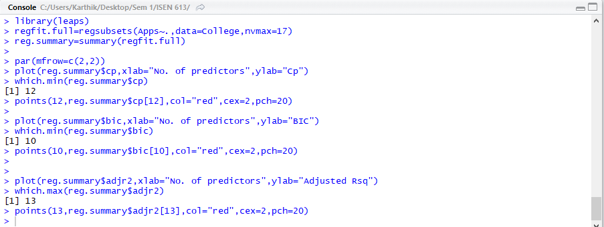

Cp -12 predictor model

BIC – 10 predictor model

AdjR2 – 13 predictor model

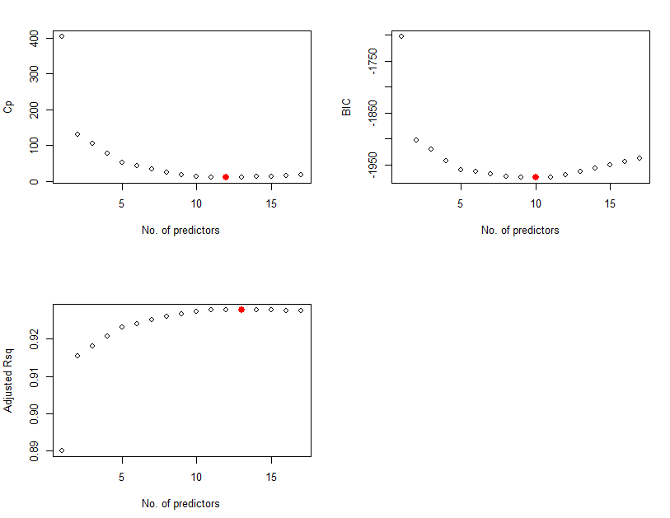

Coefficient estimates For BIC:

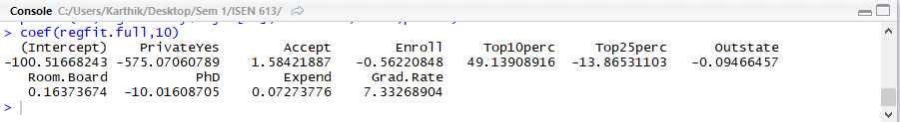

Coefficient estimates For Cp :

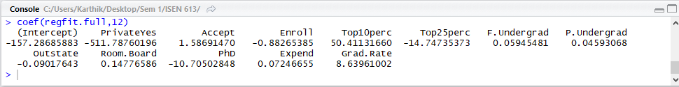

Coefficient estimates For AdjR2:

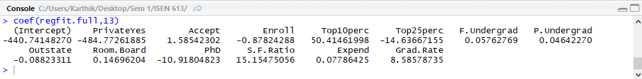

b)

FORWARD:

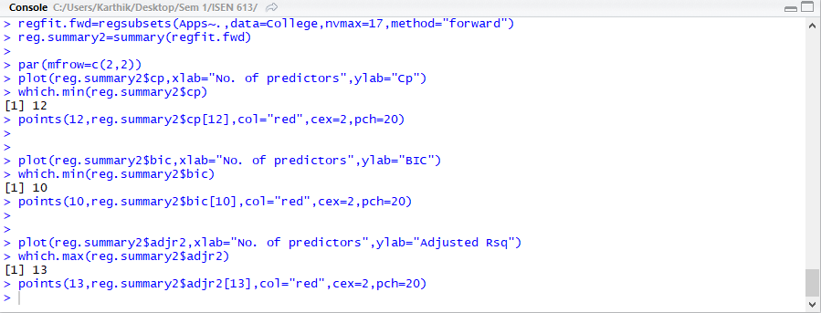

Cp -12 predictor model

BIC – 10 predictor model

AdjR2 – 13 predictor model

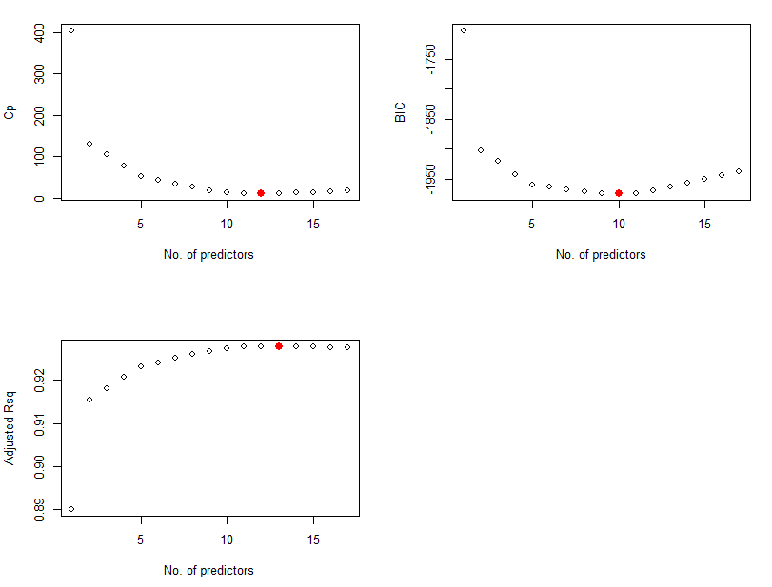

Coefficient estimates For BIC:



Coefficient estimates For Cp :



Coefficient estimates For AdjR2:



BACKWARD:

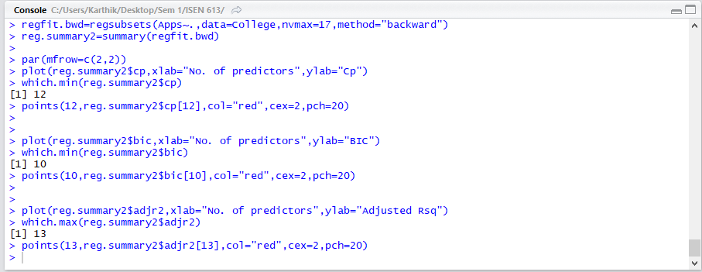

Cp -12 predictor model

BIC – 10 predictor model

AdjR2 – 13 predictor model

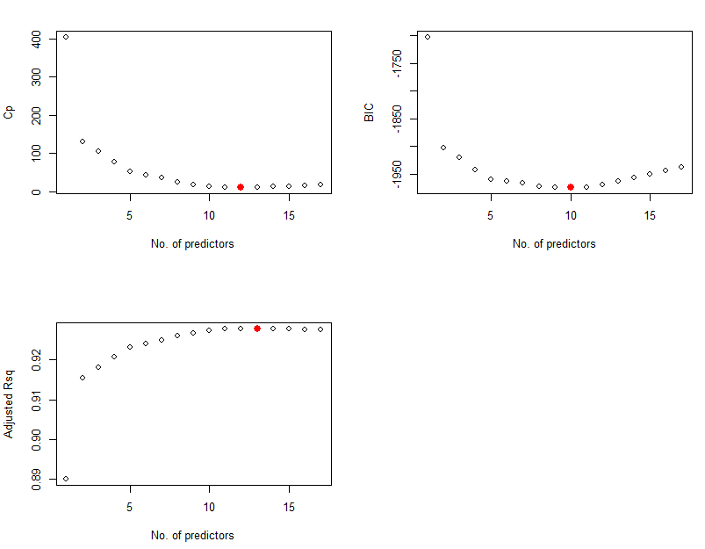

Coefficient estimates For BIC:



Coefficient estimates For Cp :



Coefficient estimates For AdjR2:



The results are the same for both best sub set selection and the forward and backward stepwise selection methods.

c)

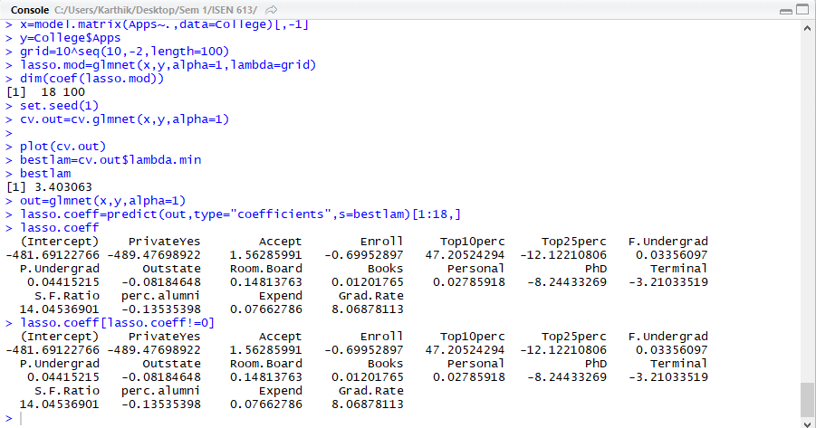

Best lambda: 3.403

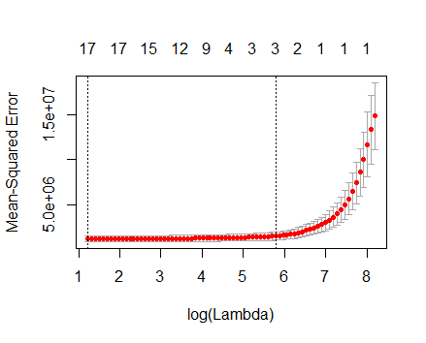

4)

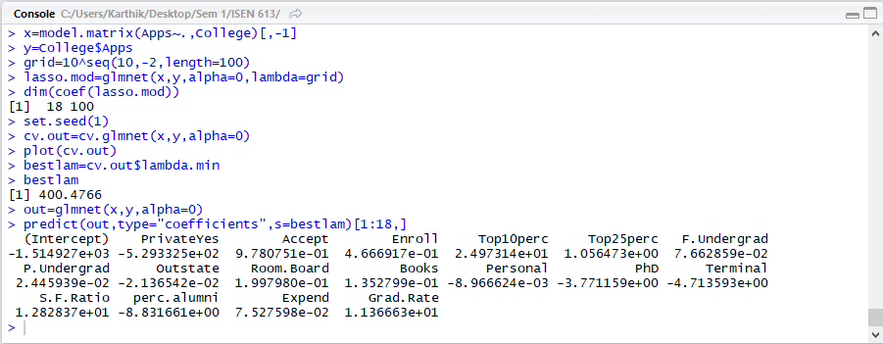

Best lambda: 400.4766

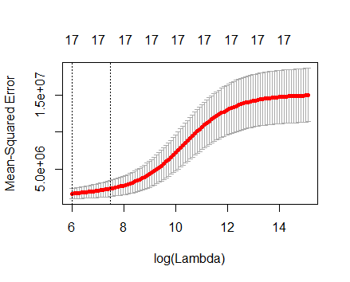

e-i)

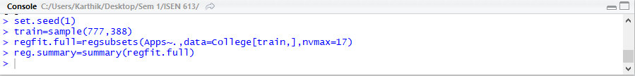

If Cp is used:

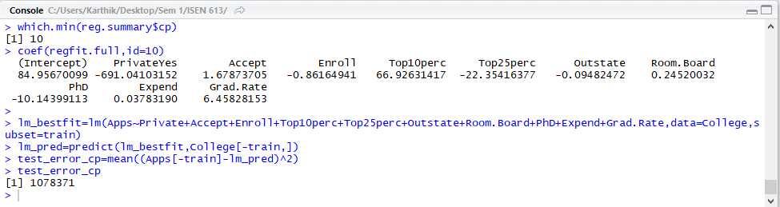

If BIC is used (Chosen in the first question as the best model):

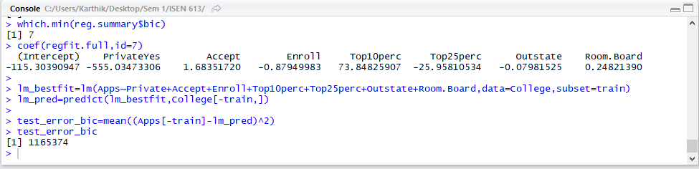

If AdjR2 is used:

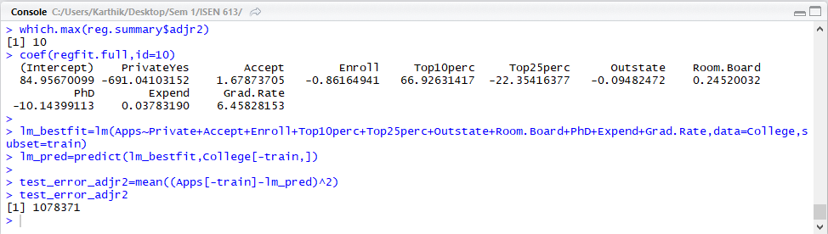

e - ii)

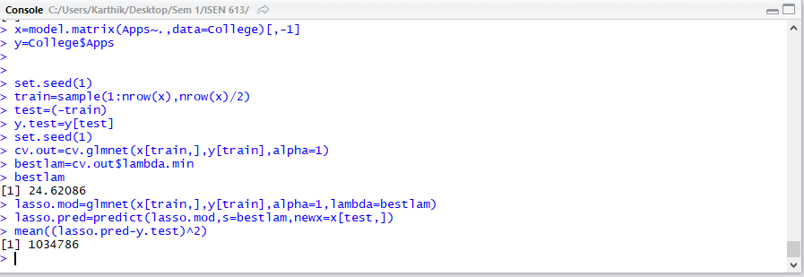

e-iii)

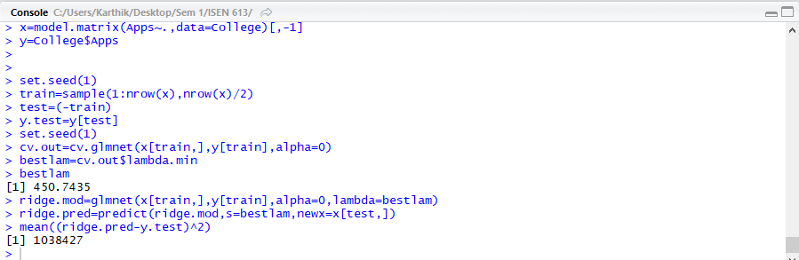

e-iv)

|  |  |
| --- | --- |
| **Model** | **Test Error** |
| Best Subset Selection (Cp) | 1078371 |
| Best Subset Selection (BIC) (CHOSEN as best among best subset selection in Q1) | 1165374 |
| Best Subset Selection (AdjR2) | 1078371 |
| **Lasso Regression** | **1034786** |
| Ridge Regression | 1038427 |

Lasso Coefficient estimates:

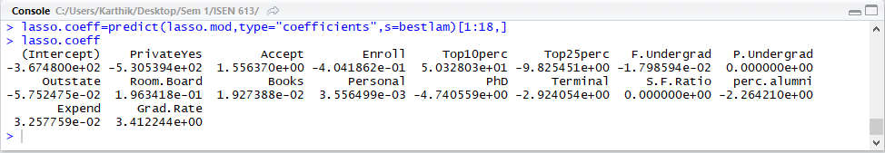

Lasso regression seems to give the lowest test error and hence is the optimal model.